**Practical – 3**

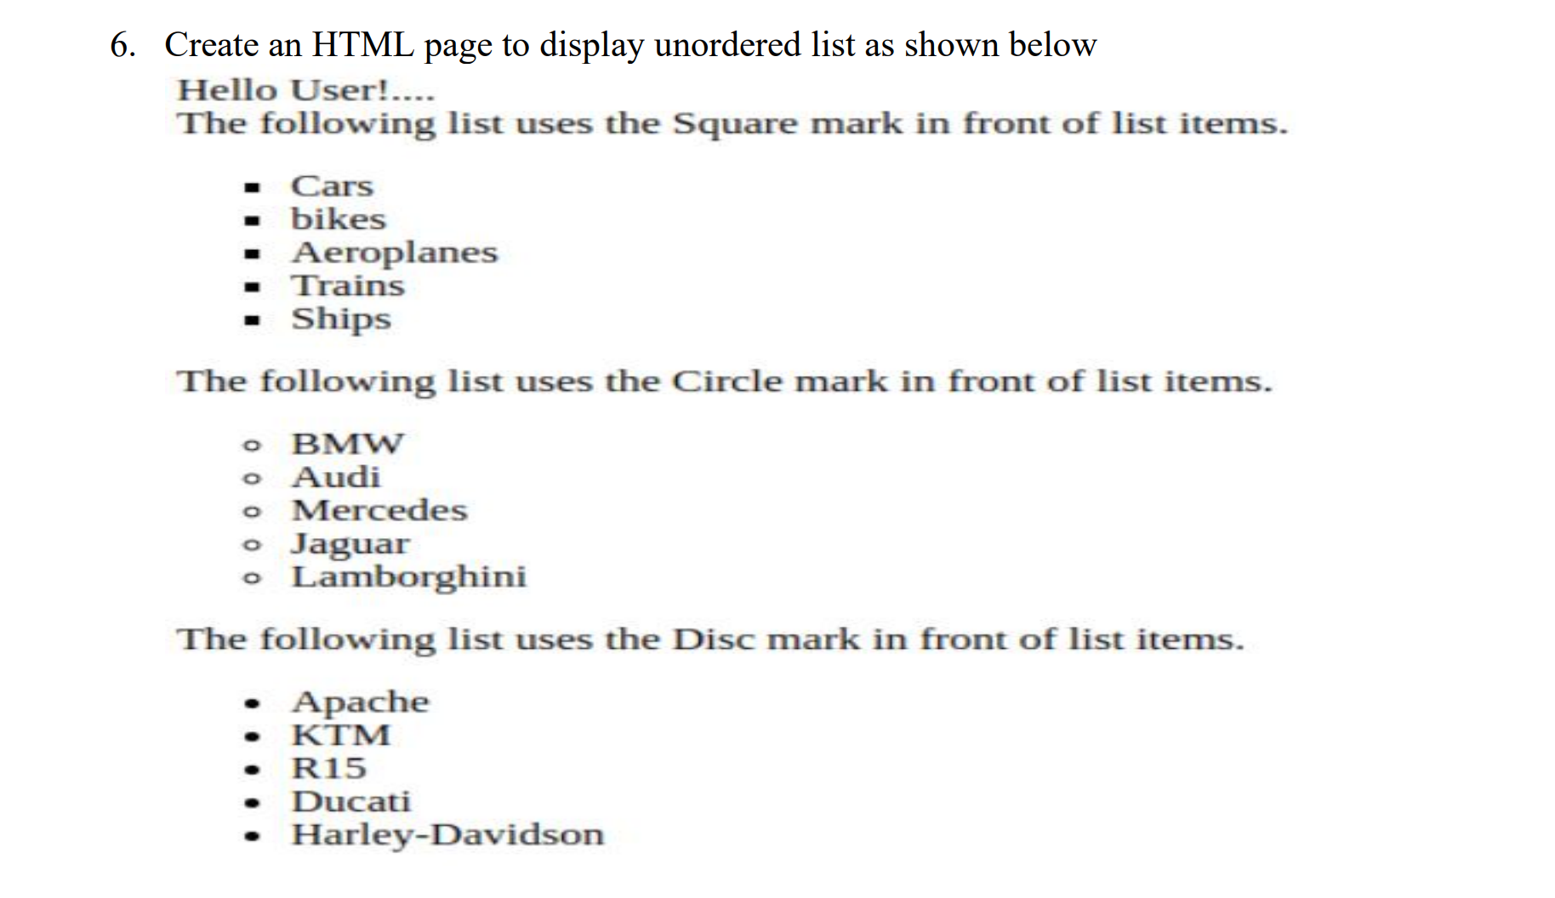

**HTML Code**

<!DOCTYPE html>

<html lang="en">

<head>

<meta charset="UTF-8">

<meta name="viewport" content="width=device-width, initial-scale=1.0">

<title>Rowspan & Colspan </title>

</head>

<body>

Hello User!....

<br>

The following list uses the Square mark in front of list items.

<ul type="square">

<li>Cars</li>

<li>bikes</li>

<li>Aeroplane</li>

<li>Trains</li>

<li>Ships</li>

</ul>

The following list uses the Circle mark in front of list items.

<ul type="circle">

<li>BMW</li>

<li>Audi</li>

<li>Mercedes</li>

<li>Jaguar</li>

<li>Lamborghini</li>

</ul>

The following list uses the Disc mark in front of the list items.

<ul type="disc">

<li>Apache</li>

<li>KTM</li>

<li>R15</li>

<li>Ducati</li>

<li>Harley Davidson</li>

</ul>

</body>

</html>

**Output**

